**Приложение 5**

Министерство образования и науки Республики Казахстан

Astana IT University

ОТЧЕТ

О выполнении программы производственной практики

База практики: ТОО “НАБ-Центр”

Студент: Санатов Еділ Ернарұлы

Образовательная программа: Программная инженерия

Группа: SE-2011

Руководители практики:

**Приложение 2**

**КАЛЕНДАРНЫЙ ПЛАН-ГРАФИК ПРОХОЖДЕНИЯ ПРАКТИКИ ОТ ПРЕДПРИЯТИЯ**

(составлять понедельно)

Санатов Еділ Ернарұлы, студента 3 курса, образовательной программы «Software Engineering», период практики с «27» февраля 2023 г. по «22» апреля 2023 г.

|  |  |  |  |  |
| --- | --- | --- | --- | --- |
| № нед. | Наименование работ | Сроки исполнения | Название подразделения или рабочего места | Отметка об исполнении |
| 1 | 2 | 3 | 4 | 5 |
| 1  нед. | Ознакомление с продуктами и услугами компании. Встретится с руководителем, чтобы обсудить роль | 27.02-06.03 | ТОО “НАБ-Центр” | 10/10 |
| 2  нед. | Ознакомится с базой данных компании и системой управления клиентами. | 06.03-13.03 | ТОО “НАБ-Центр” | 10/10 |
| 3  нед. | Начать работать над дизайном приложения | 13.03-20.03 | ТОО “НАБ-Центр” | 10/10 |
| 4  нед. | Начать работать над разработанным вами приложением. Сделать главную таблицу для заполнения | 20.03-27.03 | ТОО “НАБ-Центр” | 10/10 |
| 5  нед. | Сделать функцию для вычисления аккумуляторов | 27.03-03.04 | ТОО “НАБ-Центр” | 10/10 |
| 6  нед. | Реализовать импорт и экспорт данных на таблицу excel | 03.04-10-04 | ТОО “НАБ-Центр” | 10/10 |
| 7  нед. | Завершить сборку приложения и протестировать на разных устройствах. | 10.04-17.04 | ТОО “НАБ-Центр” | 10/10 |
| 8  нед. | Сделать дополнительные задачи, появившиеся при тестировании | 17.04-22.04 | ТОО “НАБ-Центр” | 10/10 |

*Руководитель практики от предприятия* _____________________

М.П.

*Руководитель практики от AITU* _____________________

*Подпись обучающегося* _______________

**Приложение 6**

ТОО “НАБ-Центр”

Характеристика студента, проходившего практику

Студент Санатов Еділ Ернарұлы за время прохождения практики проявил себя с положительной стороны. Согласно с планом прохождения практики, посещал место проведения практики было регулярным. К должностным обязанностям и поставленным задачам относился с особой тщательностью, проявляя интерес к работе. Опозданий не допускал. Порученные индивидуальные задачи выполнял корректно и в срок. Обладает достаточными теоретическими и практическими знаниями, необходимыми для формирования профессиональных качеств.

В коллективной работе вежлив и дружелюбен. За время прохождения практики жалоб и замечаний не получал. Еділ показал себя как пунктуальный, ответственный студент, способный решать поставленные задачи, умеющий избегать конфликтных ситуаций.

Программу прохождения практики завершил в полном объеме. По результатам практики рекомендована положительная оценка.

Рекомендуемая оценка 100

Руководитель практики

от организации, должность _____________________________ / ФИО /

М.П.

«_____» ______________ 2021 г.

Contents

Introduction 6

The theoretical part 7

The practical part 8

Conclusion 9

References: 10

Appendix 11

# Introduction

I am, Sanatov Edil Yernaruly, had an internship, from February 27 to April 22, at NAB-Center LLP in Ust-Kamenogorsk as a software engineer.

LLP "NAB-Center" is the official sales representative of the International Research and Production Company "VESTA", a dealer for the sale of batteries "HANKOOK", "MEDALIST", "NUMAX" made in Korea, "BOSCH", "VARTA". ". "Made in Germany", "BARS", "Next" made in Kazakhstan, "Mutlu" made in Turkey, "Energizer" made in the Czech Republic, "Forlux", "Vesta" made in Ukraine, "Istok", "TITAN", "VOLTMANN" production in Russia in the city of Ust-Kamenogorsk and the East Kazakhstan region. In the city of Ust-Kamenogorsk, the company has several outlets. When ordering a new batch of batteries, they must compare the quantity with the data provided by the accounting department. They do it manually by reading each battery type and brand and then uploading the data to Excel.

Project Overview:

During my internship, I worked on developing an application using React to automate the process of filling data in excel, which was a tedious and inefficient process for the company's employees. The application's primary goal was to make the data filling process more efficient and convenient for the employees, thus saving them time and increasing their productivity.

The following are the primary tasks of passing the production practice:

* A study of the technology and organization of the company's activities
* Consolidation of theoretical knowledge gained at the university.
* Familiarization with industrial technology and organization
* Gaining actual knowledge and abilities in the company's primary areas of operation
* The study also includes learning how to work effectively in a team, communication skills, and time management.

# The theoretical part

Tools and functions were used in the tasks to achieve the goal.

1. React is a widely used front-end library for building user interfaces. It was developed by Facebook and is now maintained by a community of developers. One of the key features of React is its ability to create reusable UI components. These components can be easily composed to create complex user interfaces. React also utilizes a virtual DOM (Document Object Model), which makes it faster and more efficient than traditional DOM manipulation methods. The virtual DOM allows React to update only the necessary parts of the UI when changes are made, which minimizes the number of expensive DOM operations required. This results in better performance and a smoother user experience. React also supports server-side rendering, which enables faster initial load times and better SEO (Search Engine Optimization) for web applications.

2. In addition to React, the application also uses other technologies and tools, such as JavaScript, HTML, and CSS. JavaScript is a widely used programming language for building web applications. HTML is used to create the structure of web pages, while CSS is used to style and layout the content. Together, these technologies provide the foundation for building modern web applications.

3. Material Table is a UI component for React that provides a powerful and customizable table for displaying data. It is built with Material Design principles, which is a design language developed by Google, and offers a modern and sleek look and feel. Material Table offers a range of features that make it an excellent choice for data display, including pagination, sorting, filtering, and search functionality. It also provides the ability to add custom actions to each row, such as editing or deleting data. One of the most significant advantages of Material Table is its flexibility and ease of use. It offers a straightforward API that makes it easy to customize the table's look and feel, as well as add additional functionality as needed.

# The practical part

The internship was divided into 8 weeks, and I was able to complete all the tasks assigned to me within the given time frame. The following is a detailed description of the tasks I performed during the internship:

During the first week, I was introduced to the company's products and services. I also had a meeting with my supervisor, where we discussed my role in the company and the project I would be working on. Then I spent my time familiarizing myself with the company's database and customer management system. I learned about the different tables and data structures used in the system and how they were connected. After creating wireframes and mockups I began working on the application itself. I started by creating the main table to fill, which contained information about the electronic devices for which the batteries would be calculated. I also created the necessary fields to store the required information. I created a function to calculate the required number of batteries for different electronic devices. The function used the information stored in the main table to fill, such as the amount of in db and in the store, to calculate the required number of batteries. After that I implemented data import and export to an excel table. This feature allowed users to import data from an excel table into the application and export the calculated results to an excel table. I completed building the application and performed extensive testing on different devices to ensure that it was functioning correctly. I also added some additional features, such as the ability to save and load calculations and the option to switch between different measurement systems. In the final week, I worked on additional tasks that appeared during testing. These tasks included improving the application's user interface and fixing some minor bugs. I also created documentation for the application, including a user manual and a technical guide.

# Conclusion

In conclusion, my internship at NAB-Center LLP as a software developer was a valuable experience that has enhanced my skills and knowledge in software engineering. The internship provided me with a real-world experience of working on a project, which was completely different from the projects we undertake in class. During the eight-week internship, I was able to learn about the company's products and services, familiarize myself with the company's database and customer management system, and develop an application for calculating batteries.The internship allowed me to work independently while also receiving guidance and support from my supervisor. The experience of working with a team of professionals was a great opportunity to learn and share my knowledge with others. Additionally, the project had challenges, and I had to deal with errors and problems, but I was able to overcome them and deliver the project on time. Overall, this internship has helped me improve my working mindset and has given me the confidence to work autonomously. I appreciate the opportunity to have worked at NAB-Center LLP and the support provided by guidance. This experience has prepared me for the challenges I may face in my future career as a software engineer, and I am confident that the knowledge and skills I have gained will serve me well in the future.

# References

1. <https://nab-centr.kz/>
2. Documentation. React js: <https://ru.reactjs.org/>
3. Documentation. Material table: <https://www.material-react-table.com/>

# Appendix

1. **App design**

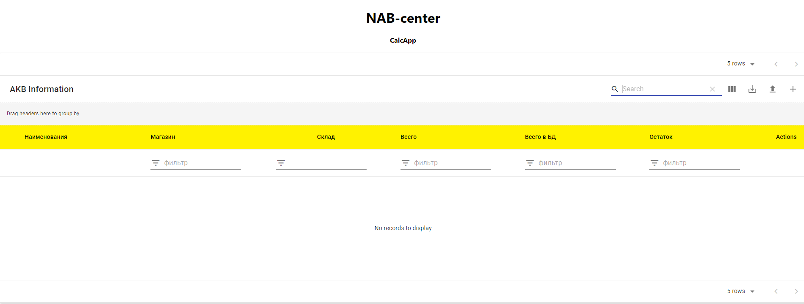

1. **Table upload**

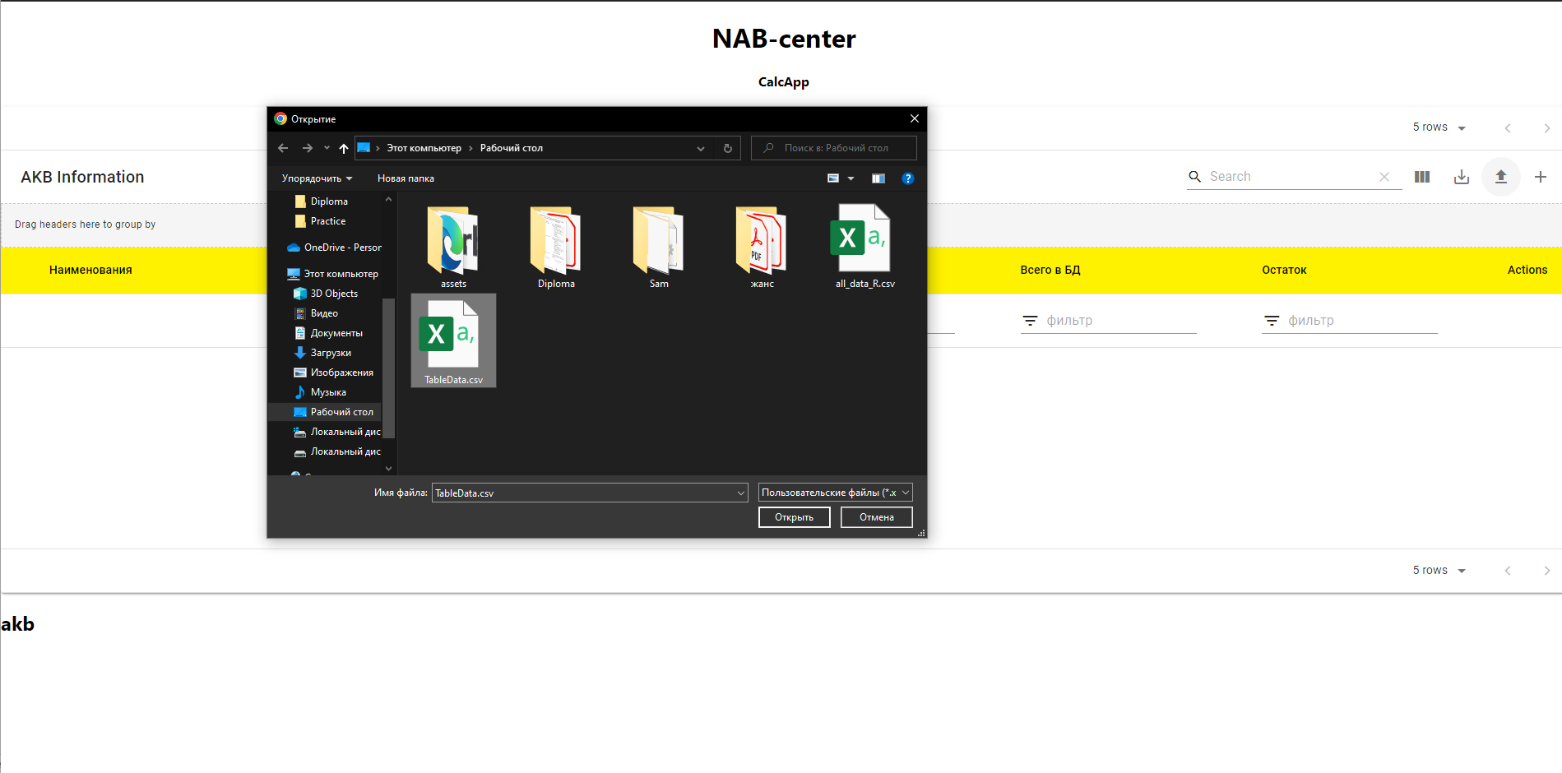

1. **Table with two column name of batteries and amount in database**

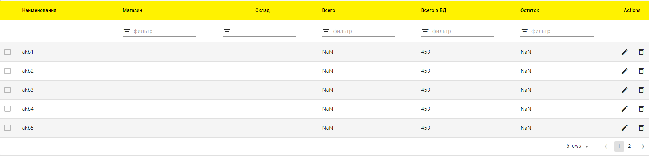

1. **Fill other columns **
2. **The application will calculate the remainder of the value, and if the number is minus, it will be marked in red.**



1. **Export to excel or pdf files**

1. **Exported excel file**

